Title

**Students Performance and Learning Outcome**

Theme

**Best practice: Developing skills of slow learners**

Name & Address of the School

**Mukat Public School**

**Patiala-Rajpura Bypass, Damanheri Road, Rajpura -140401, Punjab**

Principal

**Mrs. Gayatri Kaushal**

Contributing Teacher

**Mrs. Kuldeep Kaur**

[**kuldeepkaur03523@gmail.com**](mailto:kuldeepkaur03523@gmail.com)

**Phone:+918427478295**

Table of Contents

|  |  |  |  |
| --- | --- | --- | --- |
| S.No. | Content | | Page Number |
| 1. | Abstract | | 1 |
| 2. | Introduction | | 2 |
| 3. | Case Presentation | | 3 |
|  | a. | Identification of Problem | 3 |
|  | b. | Challenges | 3 |
|  | c. | Analysis of Problem | 3 |
|  | d. | Objectives | 4 |
|  | e. | Planning done | 4 |
|  | f. | Possible Alternative | 5 |
|  | g. | Implementation | 5 |
|  | h. | Challenges faced in Implementation | 6 |
|  | i. | Resources Involved | 6 |
| 4. | Evidences | | 7 |
| 5. | Beneficiary Satisfaction | | 8 |
| 6. | Conclusion | | 8 |
| 7. | Glossary | | 8 |
| 8. | Keywords | | 9 |
| 9. | References | | 9 |
| 10. | Appendices | | 10-11 |
| 11. | Certificate of Originality by School Principal | | 12 |
| 12. | Certificated of Originality by Author | | 13 |
| 13. | Joint NOC by School Principal and Author | | 14 |

Abstract

Challenges faced by slow learners and their respective teachers were keenly observed in a primary school. It aimed at observing and finding the everyday situation in class rooms of primary school and to find solution to such problem (academically weak slow learner and writer).

Slow learner needs some extra time and help in regular classroom. The environment factors also contribute to this slow learning.

The findings indicated that some students are not prone to take initiative in class as a result they laid back in their learning part.

Based on the findings, recommendations were made, teachers should spend more time for slow learners in classrooms talk and provide elicitations whenever it is necessary. Besides teachers should plan group work very well and give individual attention to these students.

Introduction

1. It is a known fact that all children experience school related problems at one time or another during their school years.
2. A teacher on any working day may have to deal with problems ranging from aggressive behaviour to disinterest in the learning task.
3. To uplift academically weak students a program was started naming working with slow learners.
4. How do we help the identified slow learners’ students?
5. Differentiate between the slow learner and the reluctant learner who is unmotivated, resistive, passive aggressive and uncooperative.
6. Keep the information in bits and bytes – small information.

Case Presentation

The students chosen for this case study is of grades (1-5). Total of 50 students were taken from junior school those who are academically weak.

1. Identification of Problem:-
2. Talkative
3. Do not want to do homework and classwork.
4. Slow learner and writer but giving good oral response.
5. Does not socialize much.
6. Showing behavioural problems in some cases.
7. Enjoy telling stories
8. Some of them are aggressive in nature.
9. Challenges:-
10. 60% of students come from rural areas.
11. Parents of one-third students are not literate.
12. Adverse parental attitudes education.
13. Dependence on tuitions.
14. Analysis of the Problem:-
15. Reasons given by students for their low achievement:-
16. Unfair marks
17. Poor health
18. Nervous on test
19. Worry about work
20. Cannot concentrate
21. Irregular time for sleep
22. Irregular time for eating
23. More use of mobile phone
24. Joint family
25. Reasons given by teachers for students’ low achievement:-
26. Poor foundation
27. Laziness
28. Lack of preparation
29. Negative attitude towards particular subject
30. No retention power
31. Limited ability
32. Lack of parental encouragement
33. Absences
34. Broken Homes
35. Objectives:-
36. The main objective of this case study is to know about the awareness of teachers regarding slow learners.
37. To discover what others had to say about the problems and needs of the slow learners.
38. To discover why students think they are slow learner and why teacher think some students are slow learner.
39. To discover both ways of understanding and helping the slow learner.
40. Planning done:-
    1. While planning for behaviour intervention, teacher took three areas into consideration:-
    2. Timely completion of classwork
    3. Zoning out during periods
    4. Expressing his emotions to other students in the classroom.
    5. To assist them in their classwork, a timer (used by the teacher) – mobile phone. They were asked to complete their assignment by the time the timer went off.
    6. In order to keep them not zone out, we came up with a system to keep them focused during periods. To keep students focused we allowed them to stand at their desk when they felt that they are zoning out and allowed to take five seconds to relax. It was their responsibility to take these breaks unless teacher saw that they had zoned during a period and needed a reminder with timer.
41. Possible alternatives:-
42. Peer guidance
43. Heterogeneous grouping
44. Computer assisted teaching
45. Use of educational games
46. Child study team wherein assistant teacher will help that child and other team members to work effectively.
47. Implementation:-

A program to increase students’ academic performance was developed with the help of Junior School Teachers of 1-5 grade, where 50 students were selected for the study.

* + 1. Parent Co-operation:-

It was recognized that the success of the program depends upon parent cooperation. The first step of our programme was to inform parents of those students who were academically weak. The programme was designed to recognize and accept the fact that child had been unsuccessful in school. It was important for parents to realize that the school was interested in these children and wanted to do something for them. Parents and students had to look upon the programme as an opportunity.

* + 1. Meeting individual problems:-

Keeping in mind the distinguishing characteristics of the slow learner, following guidelines were formulated for classroom methods:-

* + - 1. Short units of work was planned during the class period.
      2. To accommodate the difficulty in retention, frequent tests were to be given over short period of time.
      3. They were told to sit on front bench.
    1. Building Self Confidence:-

Group activities helped the slow learners to build their self-confidence. Keeping in line with school tradition class functions helped them a lot, as 100% participation is mandatory. As a result they usually participated and were proud of the work accomplished.

* + 1. Data Collection:-

Throughout the term, teacher used a table to keep track of these children’s behaviour and progress. Whenever there was an instance in which they zoned out during period, did not complete their classwork, had an outburst with another student etc. teacher quietly made a note. In the table, teacher recorded the date and the time, the instance that happened, anything she noticed about the situation and any comments that were made by the student at that time.

See Appendix I

* + 1. We started teaching content, not process rote learning works best but is seen as boring and aversive so we use computers and reviewed them.
    2. We kept are assignments for these students short and provided variation in assignments.
    3. More emphasis given on correction work.

1. Challenges faced in implementation:-
2. Less parents’ involvement
3. Teachers’ attitude
4. Supervision
5. To deal with these students along with whole class.
6. Extra burden on teacher.
7. Resources involved:-
8. Teachers’ team
9. Students.
10. Parents.

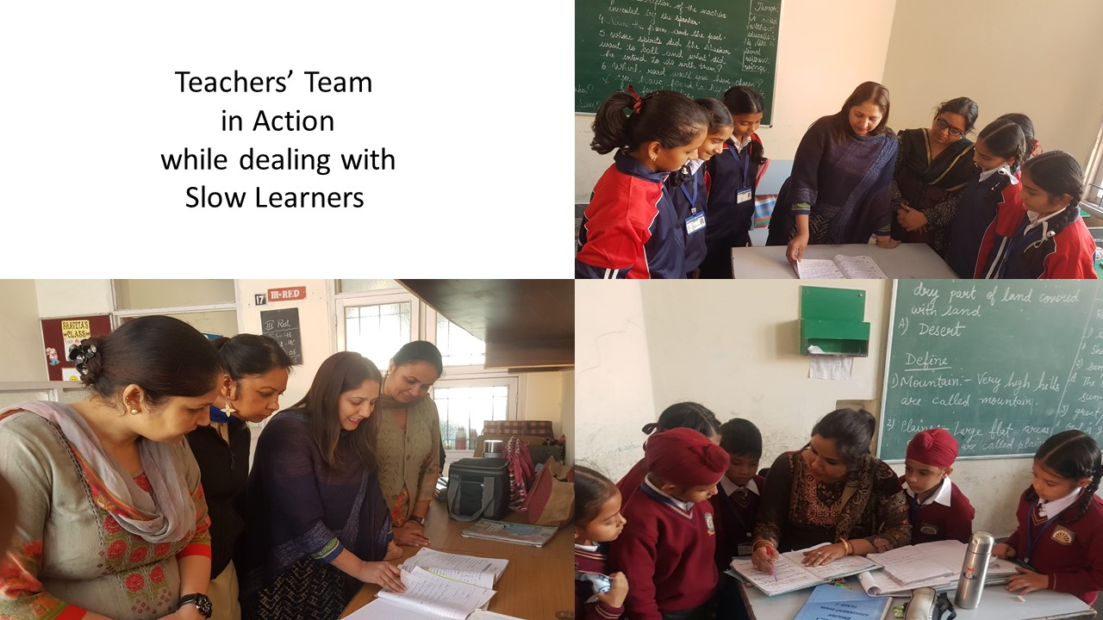**Evidences:**

Beneficiary Satisfaction:

Outcome of our programme was very positive. Out of 50 students, 50 percent got good marks in their periodic assessment, 30 percent scored average, who were earlier in failure category. But still 20 percent needed more time to improve.

See Appendix 2

Conclusion:

The study was carried out to find the low performance of some students in junior school level. Study also aimed at finding best solution to the problems faced by these students and to uplift them.

50 students from junior school were chosen who got less than 30% marks in their term examination. Teachers were given this task, where they put more emphasis on these students’ daily class work and home work. Output was very motivated, we found good improvement in 50% of the students, 30% of the students were rated average and 30 and 20% were categorized below average.

Glossary:

1. Academically: That relates to education.
2. Accomplished: Finish something successfully.
3. Aggressive: Behaving in determined or forceful manner.
4. Curriculum: Syllabus.
5. Initiative: To act before others do.
6. Instance: Example.
7. Mandatory: Compulsory.
8. Motivated: Inspired.
9. Prone: Likely to suffer from.
10. Recommendations: Suggestion to the best course of action.
11. Self Confidence: Feeling of trust in one’s abilities.
12. Skills: Expertise.
13. Slow Learners: Learning at the rate below average when compared to peers of same age.
14. Socialize: Mix socially with others
15. Talkative: One who talks a lot.
16. Uplift: Boost
17. Zone out: Loose concentration

Keywords:

1. Slow learning
2. Identification
3. School programmes
4. Curriculum

References:

Brut c. the backward child, (2nd ed), University of London, Press 1946

Appendix 1

|  |  |  |  |  |  |
| --- | --- | --- | --- | --- | --- |
| Name | Attendance  Weekly | Class Work Performance  (zoning out or not, if yes for how many times in a period of 40 minutes) | Home Work Done | Teacher’s effort | |
| Anshu | 5/6 | Zooming out 5 times | No | Giving extra time | Informing parents weekly about performance |

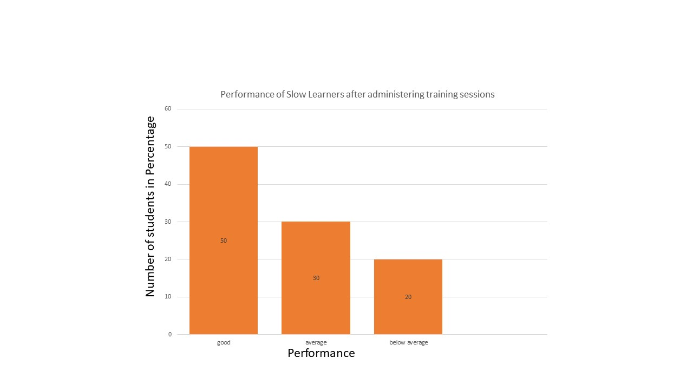Appendix 2

